Coursematerial edx Linux Basis

Boot process & Linux Kernel

Bios
Starting an x86-based Linux system involves a number of steps. When the computer is powered on, the Basic Input/Output System (BIOS) initializes the hardware,
including the screen and keyboard, and tests the main memory. This process is also called POST (Power On Self Test).
The BIOS software is stored on a ROM chip on the motherboard. After this, the remainder of the boot process is controlled by the operating system (OS).

Master Boot Record (MBR) and Boot Loader
Once the POST is completed, the system control passes from the BIOS to the boot loader. The boot loader is usually stored on one of the hard disks in the system,
either in the boot sector (for traditional BIOS/MBR systems) or the EFI partition (for more recent (Unified) Extensible Firmware Interface or EFI/UEFI systems).
Up to this stage, the machine does not access any mass storage media. Thereafter, information on date, time, and the most important peripherals are loaded from the
CMOS values (after a technology used for the battery-powered memory store which allows the system to keep track of the date and time even when it is powered off).

A number of boot loaders exist for Linux; the most common ones are GRUB (for GRand Unified Boot loader), ISOLINUX (for booting from removable media),
and DAS U-Boot (for booting on embedded devices/appliances). Most Linux boot loaders can present a user interface for choosing alternative options for booting Linux,
and even other operating systems that might be installed. When booting Linux, the boot loader is responsible for loading the kernel image and the initial RAM disk or
filesystem (which contains some critical files and device drivers needed to start the system) into memory.

Boot Loader in Action
The boot loader has two distinct stages:
For systems using the BIOS/MBR method, the boot loader resides at the first sector of the hard disk, also known as the Master Boot Record (MBR).
The size of the MBR is just 512 bytes. In this stage, the boot loader examines the partition table and finds a bootable partition. Once it finds a bootable partition,
it then searches for the second stage boot loader, for example GRUB, and loads it into RAM (Random Access Memory). For systems using the EFI/UEFI method,
UEFI firmware reads its Boot Manager data to determine which UEFI application is to be launched and from where (i.e. from which disk and partition the EFI partition
can be found). The firmware then launches the UEFI application, for example GRUB, as defined in the boot entry in the firmware's boot manager.
This procedure is more complicated, but more versatile than the older MBR methods.

The second stage boot loader resides under /boot. A splash screen is displayed, which allows us to choose which operating system (OS) to boot.
After choosing the OS, the boot loader loads the kernel of the selected operating system into RAM and passes control to it. Kernels are almost always compressed,
so its first job is to uncompress itself. After this, it will check and analyze the system hardware and initialize any hardware device drivers built into the kernel.

Initial RAM Disk
The initramfs filesystem image contains programs and binary files that perform all actions needed to mount the proper root filesystem,
like providing kernel functionality for the needed filesystem and device drivers for mass storage controllers with a facility called udev (for user device),
which is responsible for figuring out which devices are present, locating the device drivers they need to operate properly, and loading them.
After the root filesystem has been found, it is checked for errors and mounted.
The mount program instructs the operating system that a filesystem is ready for use, and associates it with a particular point in the overall hierarchy of
the filesystem (the mount point). If this is successful, the initramfs is cleared from RAM and the init program on the root filesystem (/sbin/init) is executed.
init handles the mounting and pivoting over to the final real root filesystem. If special hardware drivers are needed before the mass storage can be accessed,
they must be in the initramfs image.

Text-Mode Login

Near the end of the boot process, init starts a number of text-mode login prompts. These enable you to type your username, followed by your password,
and to eventually get a command shell. However, if you are running a system with a graphical login interface, you will not see these at first.
Command Line Operations, the terminals which run the command shells can be accessed using the ALT key plus a function key.
Most distributions start six text terminals and one graphics terminal starting with F1 or F2. Within a graphical environment, switching to a text console
requires pressing CTRL-ALT + the appropriate function key (with F7 or F1 leading to the GUI).

Usually, the default command shell is bash (the GNU Bourne Again Shell), but there are a number of other advanced command shells available.
The shell prints a text prompt, indicating it is ready to accept commands; after the user types the command and presses Enter, the command is executed,
and another prompt is displayed after the command is done.

The Linux Kernel
The boot loader loads both the kernel and an initial RAM–based file system (initramfs) into memory, so it can be used directly by the kernel.
When the kernel is loaded in RAM, it immediately initializes and configures the computer’s memory and also configures all the hardware attached to the system.
This includes all processors, I/O subsystems, storage devices, etc. The kernel also loads some necessary user space applications.

/sbin/init and Services
Once the kernel has set up all its hardware and mounted the root filesystem, the kernel runs /sbin/init. This then becomes the initial process,
which then starts other processes to get the system running. Most other processes on the system trace their origin ultimately to init;
exceptions include the so-called kernel processes. These are started by the kernel directly, and their job is to manage internal operating system details.

Besides starting the system, init is responsible for keeping the system running and for shutting it down cleanly. One of its responsibilities is to act when necessary
as a manager for all non-kernel processes; it cleans up after them upon completion, and restarts user login services as needed when users log in and out, and does
the same for other background system services.

Traditionally, this process startup was done using conventions that date back to the 1980s and the System V variety of UNIX. This serial process had the system passing
through a sequence of runlevels containing collections of scripts that start and stop services. Each runlevel supported a different mode of running the system. Within each
runlevel, individual services could be set to run, or to be shut down if running.
However, all major distributions have moved away from this sequential runlevel method of system initialization, although they usually emulate many System V utilities
for compatibility purposes. Next, we discuss the new methods, of which systemd has become dominant.

systemd Features
Systems with systemd start up faster than those with earlier init methods. This is largely because it replaces a serialized set of steps with aggressive parallelization
techniques, which permits multiple services to be initiated simultaneously. Complicated startup shell scripts are replaced with simpler configuration files, which
enumerate what has to be done before a service is started, how to execute service startup, and what conditions the service should indicate have been accomplished
when startup is finished. One thing to note is that /sbin/init now just points to /lib/systemd/systemd; i.e. systemd takes over the init process.

One systemd command (systemctl) is used for most basic tasks. While we have not yet talked about working at the command line, here is a brief listing of its use:
Starting, stopping, restarting a service (using httpd, the Apache web server, as an example) on a currently running system:
$ sudo systemctl start|stop|restart httpd.service
Enabling or disabling a system service from starting up at system boot:
$ sudo systemctl enable|disable httpd.service
In most cases, the .service can be omitted. There are many technical differences with older methods that lie beyond the scope of our discussion.

Linux Filesystem

Filesystem
Think of a refrigerator that has multiple shelves that can be used for storing various items. These shelves help you organize the grocery items by shape, size, type, etc.
The same concept applies to a filesystem, which is the embodiment of a method of storing and organizing arbitrary collections of data in a human-usable form.
Different types of filesystems supported by Linux:
Conventional disk filesystems: ext3, ext4, XFS, Btrfs, JFS, NTFS, vfat, exfat, etc.
Flash storage filesystems: ubifs, jffs2, yaffs, etc.
Database filesystems
Special purpose filesystems: procfs, sysfs, tmpfs, squashfs, debugfs, fuse, etc.
This section will describe the standard filesystem layout shared by most Linux distributions.

Partitions and Filesystems
A partition is a physically contiguous section of a disk, or what appears to be so in some advanced setups.
A filesystem is a method of storing/finding files on a hard disk (usually in a partition).
One can think of a partition as a container in which a filesystem resides, although in some circumstances,
a filesystem can span more than one partition if one uses symbolic links, which we will discuss much later.
A comparison between filesystems in Windows and Linux is given in the accompanying table:
Windows Linux
Partition Disk1 /dev/sda1
Filesystem Type NTFS/VFAT EXT3/EXT4/XFS/BTRFS...
Mounting Parameters DriveLetter MountPoint
Base Folder (where OS stored) C: \

The Filesystem Hierarchy Standard
Linux systems store their important files according to a standard layout called the Filesystem Hierarchy Standard (FHS),
which has long been maintained by the Linux Foundation. For more information, take a look at the following document:
"Filesystem Hierarchy Standard" created by LSB Workgroup. Having a standard is designed to ensure that users, administrators,
and developers can move between distributions without having to re-learn how the system is organized.

Linux uses the ‘/’ character to separate paths (unlike Windows, which uses ‘\’), and does not have drive letters. Multiple drives and/or partitions
are mounted as directories in the single filesystem. Removable media such as USB drives and CDs and DVDs will show up as mounted at
/run/media/yourusername/disklabel for recent Linux systems, or under /media for older distributions. For example, if your username is student a
USB pen drive labeled FEDORA might end up being found at /run/media/student/FEDORA, and a file README.txt on that disc would be at
/run/media/student/FEDORA/README.txt.

More About the Filesystem Hierarchy Standard
All Linux filesystem names are case-sensitive, so /boot, /Boot, and /BOOT represent three different directories (or folders). Many distributions
distinguish between core utilities needed for proper system operation and other programs, and place the latter in directories under /usr (think user).

The Command Line

Most input lines entered at the shell prompt have three basic elements:
Command
Options
Arguments
The command is the name of the program you are executing. It may be followed by one or more options (or switches) that modify what the
command may do. Options usually start with one or two dashes, for example, -p or --print, in order to differentiate them from arguments, which
represent what the command operates on.
However, plenty of commands have no options, no arguments, or neither. In addition, other elements (such as setting environment variables)
can also appear on the command line when launching a task.

GUI - Graphical User Interface

X Window System
Generally, in a Linux desktop system, the X Window System is loaded as one of the final steps in the boot process. It is often just called X.
A service called the Display Manager keeps track of the displays being provided and loads the X server (so-called, because it provides graphical
services to applications, sometimes called X clients). The display manager also handles graphical logins and starts the appropriate desktop environment after
a user logs in. X is rather old software; it dates back to the mid 1980s and, as such, has certain deficiencies on modern systems (for example, with security),
as it has been stretched rather far from its original purposes. A newer system, known as Wayland, is gradually superseding it and is the default display system for
Fedora, RHEL 8, and other recent distributions. For the most part, it looks just like X to the user, although under the hood it is quite different.

GUI Startup
When you install a desktop environment, the X display manager starts at the end of the boot process. It is responsible for starting the graphics system,
logging in the user, and starting the user’s desktop environment. You can often select from a choice of desktop environments when logging in to the system.
The default display manager for GNOME is called gdm. Other popular display managers include lightdm (used on Ubuntu before version 18.04 LTS) and kdm (associated with KDE).

GNOME Desktop Environment
GNOME is a popular desktop environment with an easy-to-use graphical user interface. It is bundled as the default desktop environment for most
Linux distributions, including Red Hat Enterprise Linux (RHEL), Fedora, CentOS, SUSE Linux Enterprise, Ubuntu and Debian. GNOME has menu-based
navigation and is sometimes an easy transition to accomplish for Windows users. However, as you will see, the look and feel can be quite different across distributions,
even if they are all using GNOME. Another common desktop environment very important in the history of Linux and also widely used is KDE, which has often been
used in conjunction with SUSE and openSUSE. Other alternatives for a desktop environment include Unity (present on older Ubuntu, but still based on GNOME),
XFCE and LXDE. As previously mentioned, most desktop environments follow a similar structure to GNOME, and we will restrict ourselves mostly to it to keep things
less complex.

Chapter 7: Command Line Operation Basic Operations

Basic Operations
In this section, we will discuss how to accomplish basic operations from the command line. These include how to log in and log out from the system, restart or shut down the system, locate applications, access directories, identify absolute and relative paths, and explore the filesystem.
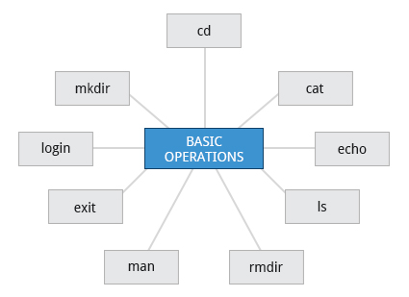

Locating Applications
Depending on the specifics of your particular distribution's policy, programs and software packages can be installed in various directories. In general, executable programs and scripts should live in the /bin, /usr/bin, /sbin, /usr/sbin directories, or somewhere under /opt. They can also appear in /usr/local/bin and /usr/local/sbin, or in a directory in a user's account space, such as /home/student/bin.
One way to locate programs is to employ the which utility. For example, to find out exactly where the diff program resides on the filesystem:
$ which diff
/usr/bin/diff
If which does not find the program, whereis is a good alternative because it looks for packages in a broader range of system directories:
$ whereis diff
diff: /usr/bin/diff /usr/share/man/man1/diff.1.gz /usr/share/man/man1p/diff.1p.gz
as well as locating source and man files packaged with the program.

Understanding Absolute and Relative Paths
There are two ways to identify paths:
    - Absolute pathname
An absolute pathname begins with the root directory and follows the tree, branch by branch, until it reaches the desired directory or file. Absolute paths always start with /.
    - Relative pathname
A relative pathname starts from the present working directory. Relative paths never start with /.
Multiple slashes (/) between directories and files are allowed, but all but one slash between elements in the pathname is ignored by the system. ////usr//bin is valid, but seen as /usr/bin by the system.
Most of the time, it is most convenient to use relative paths, which require less typing. Usually, you take advantage of the shortcuts provided by: . (present directory), .. (parent directory) and ~ (your home directory).
For example, suppose you are currently working in your home directory and wish to move to the /usr/bin directory. The following two ways will bring you to the same directory from your home directory:
    - Absolute pathname method
$ cd /usr/bin
    - Relative pathname method
$ cd ../../usr/bin
In this case, the absolute pathname method requires less typing.

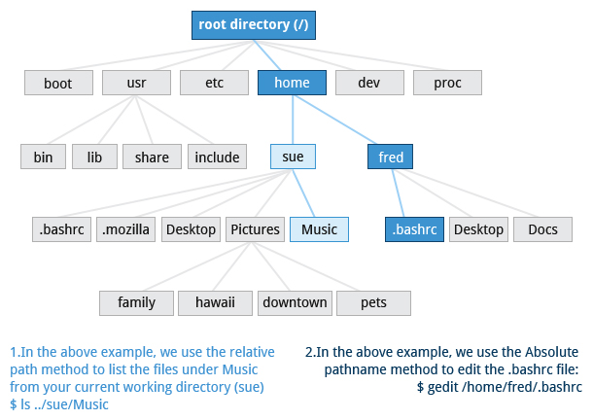

Hard Links
The ln utility is used to create hard links and (with the -s option) soft links, also known as symbolic links or symlinks. These two kinds of links are very useful in UNIX-based operating systems.
Suppose that file1 already exists. A hard link, called file2, is created with the command:
$ ln file1 file2
Note that two files now appear to exist. However, a closer inspection of the file listing shows that this is not quite true.
$ ls -li file1 file2
The -i option to ls prints out in the first column the inode number, which is a unique quantity for each file object. This field is the same for both of these files; what is really going on here is that it is only one file, but it has more than one name associated with it, as is indicated by the 2 that appears in the ls output. Thus, there was already another object linked to file1 before the command was executed.
Hard links are very useful and they save space, but you have to be careful with their use, sometimes in subtle ways. For one thing, if you remove either file1 or file2 in the example, the inode object (and the remaining file name) will remain, which might be undesirable, as it may lead to subtle errors later if you recreate a file of that name.
If you edit one of the files, exactly what happens depends on your editor; most editors, including vi and gedit, will retain the link by default, but it is possible that modifying one of the names may break the link and result in the creation of two objects.

Soft (Symbolic) Links
Soft (or Symbolic) links are created with the -s option, as in:

$ ln -s file1 file3
$ ls -li file1 file3

Notice file3 no longer appears to be a regular file, and it clearly points to file1 and has a different inode number.

Symbolic links take no extra space on the filesystem (unless their names are very long). They are extremely convenient, as they can easily be modified to point to different places. An easy way to create a shortcut from your home directory to long pathnames is to create a symbolic link.

Unlike hard links, soft links can point to objects even on different filesystems, partitions, and/or disks and other media, which may or may not be currently available or even exist. In the case where the link does not point to a currently available or existing object, you obtain a dangling link.

Navigating the Directory History
The cd command remembers where you were last, and lets you get back there with cd -. For remembering more than just the last directory visited, use pushd to change the directory instead of cd; this pushes your starting directory onto a list. Using popd will then send you back to those directories, walking in reverse order (the most recent directory will be the first one retrieved with popd). The list of directories is displayed with the dirs command.

Viewing Files
Command | Usage
cat | Used for viewing files that are not very long; it does not provide any scroll-back.
tac | Used to look at a file backwards, starting with the last line.
less | Used to view larger files because it is a paging program. It pauses at each screen full of text, provides scroll-back capabilities, and lets you search and navigate within the file.  NOTE: Use / to search for a pattern in the forward direction and ? for a pattern in the backward direction. An older program named more is still used, but has fewer capabilities: "less is more".
tail | Used to print the last 10 lines of a file by default. You can change the number of lines by doing -n 15 or just -15 if you wanted to look at the last 15 lines instead of the default.
head | The opposite of tail; by default, it prints the first 10 lines of a file.

Standard File Streams
When commands are executed, by default there are three standard file streams (or descriptors) always open for use: standard input (standard in or stdin), standard output (standard out or stdout) and standard error (or stderr).

Name | Symbolic Name | Value | Example
standard input | stdin | 0 | keyboard
standard output | stdout | 1 | terminal
standard error | stderr | 2 | log file

Usually, stdin is your keyboard, and stdout and stderr are printed on your terminal. stderr is often redirected to an error logging file, while stdin is supplied by directing input to come from a file or from the output of a previous command through a pipe. stdout is also often redirected into a file. Since stderr is where error messages are written, usually nothing will go there.
In Linux, all open files are represented internally by what are called file descriptors. Simply put, these are represented by numbers starting at zero. stdin is file descriptor 0, stdout is file descriptor 1, and stderr is file descriptor 2. Typically, if other files are opened in addition to these three, which are opened by default, they will start at file descriptor 3 and increase from there.
On the next page and in the chapters ahead, you will see examples which alter where a running command gets its input, where it writes its output, or where it prints diagnostic (error) messages.

I/O Redirection
Through the command shell, we can redirect the three standard file streams so that we can get input from either a file or another command, instead of from our keyboard, and we can write output and errors to files or use them to provide input for subsequent commands.

For example, if we have a program called do_something that reads from stdin and writes to stdout and stderr, we can change its input source by using the less-than sign (<) followed by the name of the file to be consumed for input data:

$ do_something < input-file

If you want to send the output to a file, use the greater-than sign (>) as in:

$ do_something > output-file

Because stderr is not the same as stdout, error messages will still be seen on the terminal windows in the above example.

If you want to redirect stderr to a separate file, you use stderr’s file descriptor number (2), the greater-than sign (>), followed by the name of the file you want to hold everything the running command writes to stderr:

$ do_something 2> error-file

NOTE: By the same logic, do_something 1> output-file is the same as do_something > output-file.

A special shorthand notation can send anything written to file descriptor 2 (stderr) to the same place as file descriptor 1 (stdout): 2>&1.

$ do_something > all-output-file 2>&1

bash permits an easier syntax for the above:

$ do_something >& all-output-file

Pipes
The UNIX/Linux philosophy is to have many simple and short programs (or commands) cooperate together to produce quite complex results, rather than have one complex program with many possible options and modes of operation. In order to accomplish this, extensive use of pipes is made. You can pipe the output of one command or program into another as its input.
In order to do this, we use the vertical-bar, pipe symbol (|), between commands as in:
$ command1 | command2 | command3
The above represents what we often call a pipeline, and allows Linux to combine the actions of several commands into one. This is extraordinarily efficient because command2 and command3 do not have to wait for the previous pipeline commands to complete before they can begin hacking at the data in their input streams; on multiple CPU or core systems, the available computing power is much better utilized and things get done quicker.
Furthermore, there is no need to save output in (temporary) files between the stages in the pipeline, which saves disk space and reduces reading and writing from disk, which is often the slowest bottleneck in getting something done.

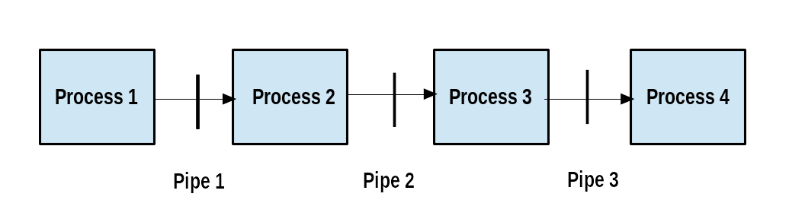
Pipeline

locate
The locate utility program performs a search taking advantage of a previously constructed database of files and directories on your system, matching all entries that contain a specified character string. This can sometimes result in a very long list.
To get a shorter (and possibly more relevant) list, we can use the grep program as a filter. grep will print only the lines that contain one or more specified strings, as in:
$ locate zip | grep bin
which will list all the files and directories with both zip and bin in their name. We will cover grep in much more detail later. Notice the use of | to pipe the two commands together.
locate utilizes a database created by a related utility, updatedb. Most Linux systems run this automatically once a day. However, you can update it at any time by just running updatedb from the command line as the root user.

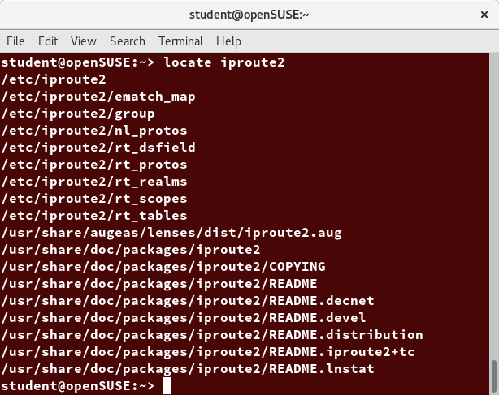
locate

Wildcards and Matching File Names
You can search for a filename containing specific characters using wildcards.

Wildcard | Result
? | Matches any single character
* | Matches any string of characters
[set] | Matches any character in the set of characters, for example [adf] will match any occurrence of a, d, or f
[!set] | Matches any character not in the set of characters

To search for files using the ? wildcard, replace each unknown character with ?. For example, if you know only the first two letters are 'ba' of a three-letter filename with an extension of .out, type ls ba?.out.
To search for files using the * wildcard, replace the unknown string with *. For example, if you remember only that the extension was .out, type ls *.out.

The find Program

find is an extremely useful and often-used utility program in the daily life of a Linux system administrator. It recurses down the filesystem tree from any particular directory (or set of directories) and locates files that match specified conditions. The default pathname is always the present working directory.
For example, administrators sometimes scan for potentially large core files (which contain diagnostic information after a program fails) that are more than several weeks old in order to remove them.
It is also common to remove files in inessential or outdated files in /tmp (and other volatile directories, such as those containing cached files) that have not been accessed recently. Many Linux distributions use shell scripts that run periodically (through cron usually) to perform such house cleaning.

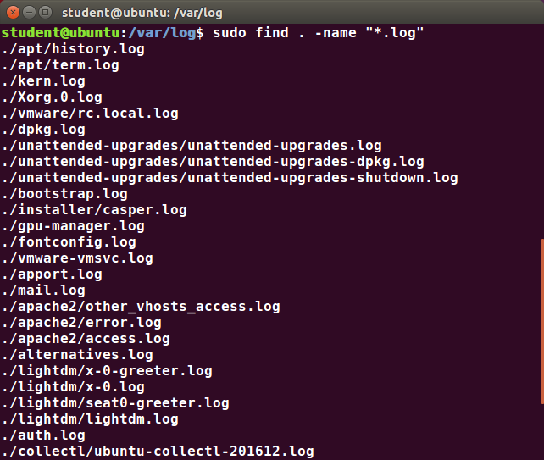
find
When no arguments are given, find lists all files in the current directory and all of its subdirectories. Commonly used options to shorten the list include -name (only list files with a certain pattern in their name), -iname (also ignore the case of file names), and -type (which will restrict the results to files of a certain specified type, such as d for directory, l for symbolic link, or f for a regular file, etc.).
Searching for files and directories named gcc:
$ find /usr -name gcc
Searching only for directories named gcc:
$ find /usr -type d -name gcc
Searching only for regular files named gcc:
$ find /usr -type f -name gcc

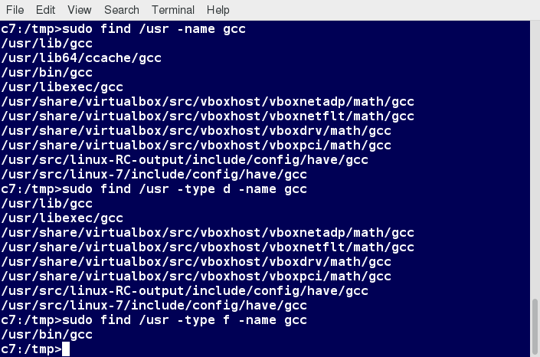
Using find

Using Advanced find Options
Another good use of find is being able to run commands on the files that match your search criteria. The -exec option is used for this purpose.
To find and remove all files that end with .swp:
$ find -name "*.swp" -exec rm {} ’;’
The {} (squiggly brackets) is a placeholder that will be filled with all the file names that result from the find expression, and the preceding command will be run on each one individually.
Please note that you have to end the command with either ‘;’ (including the single-quotes) or "\;". Both forms are fine.
One can also use the -ok option, which behaves the same as -exec, except that find will prompt you for permission before executing the command. This makes it a good way to test your results before blindly executing any potentially dangerous commands.

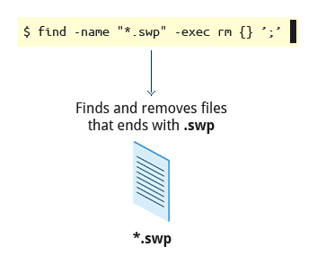
Finding and Removing Files that End with .swp

Finding Files Based on Time and Size
It is sometimes the case that you wish to find files according to attributes, such as when they were created, last used, etc., or based on their size. It is easy to perform such searches.
To find files based on time:
$ find / -ctime 3
Here, -ctime is when the inode metadata (i.e. file ownership, permissions, etc.) last changed; it is often, but not necessarily, when the file was first created. You can also search for accessed/last read (-atime) or modified/last written (-mtime) times. The number is the number of days and can be expressed as either a number (n) that means exactly that value, +n, which means greater than that number, or -n, which means less than that number. There are similar options for times in minutes (as in -cmin, -amin, and -mmin).
To find files based on sizes:
$ find / -size 0
Note the size here is in 512-byte blocks, by default; you can also specify bytes (c), kilobytes (k), megabytes (M), gigabytes (G), etc. As with the time numbers above, file sizes can also be exact numbers (n), +n or -n. For details, consult the man page for find.
For example, to find files greater than 10 MB in size and running a command on those files:
$ find / -size +10M -exec command {} ’;’

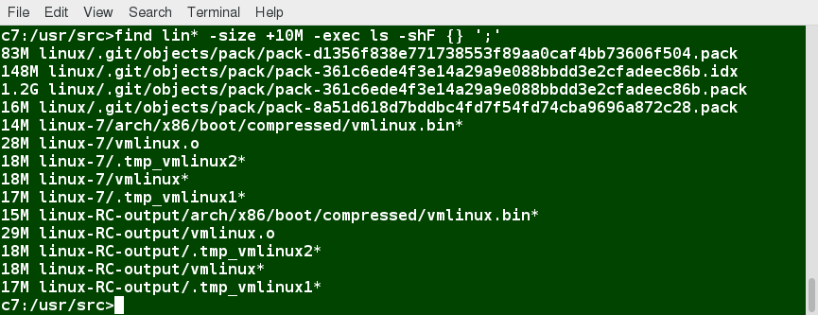
Finding Files Based on Time and Size

